Bhuwan Sapkota

#101101219

csci 3453

Lab2 sample output

Output with command

**./myscheduler input4 output 0**

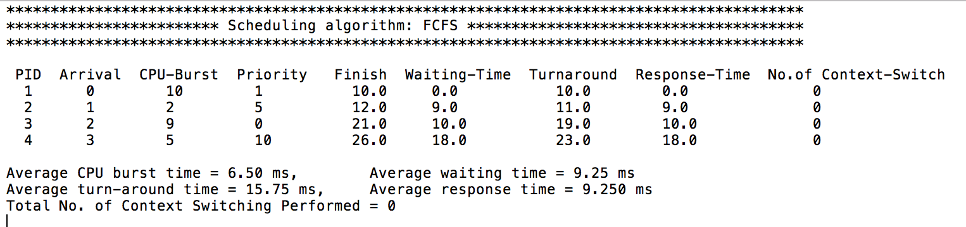

Output with command

**./myscheduler input10 output 0**

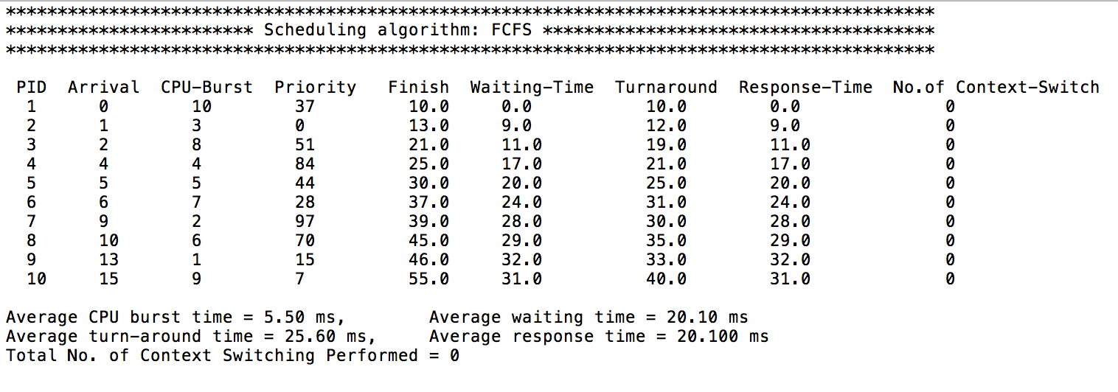

Output with command

**./myscheduler input100 output 0**

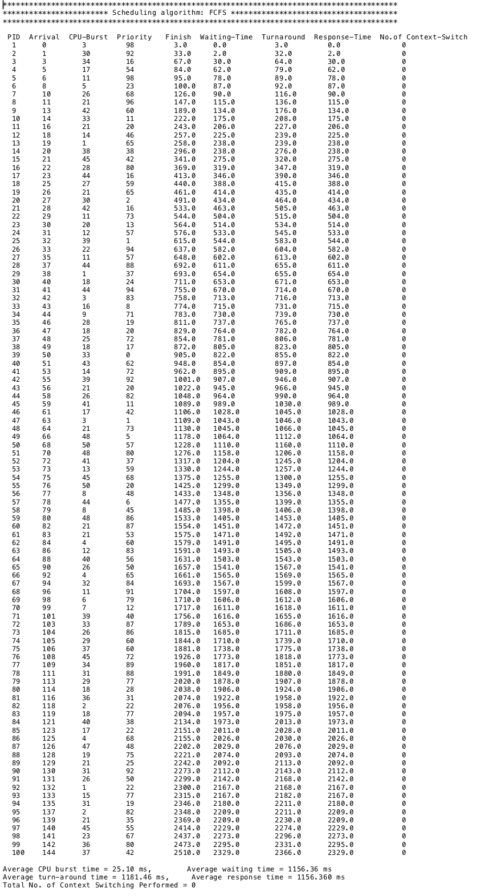

Output with command

**./myscheduler input4 output 1**

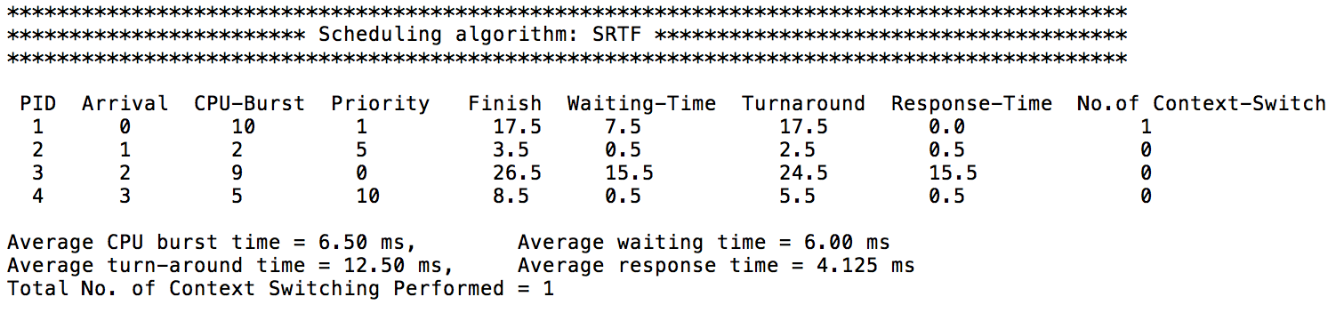

Output with command

**./myscheduler input10 output 1**

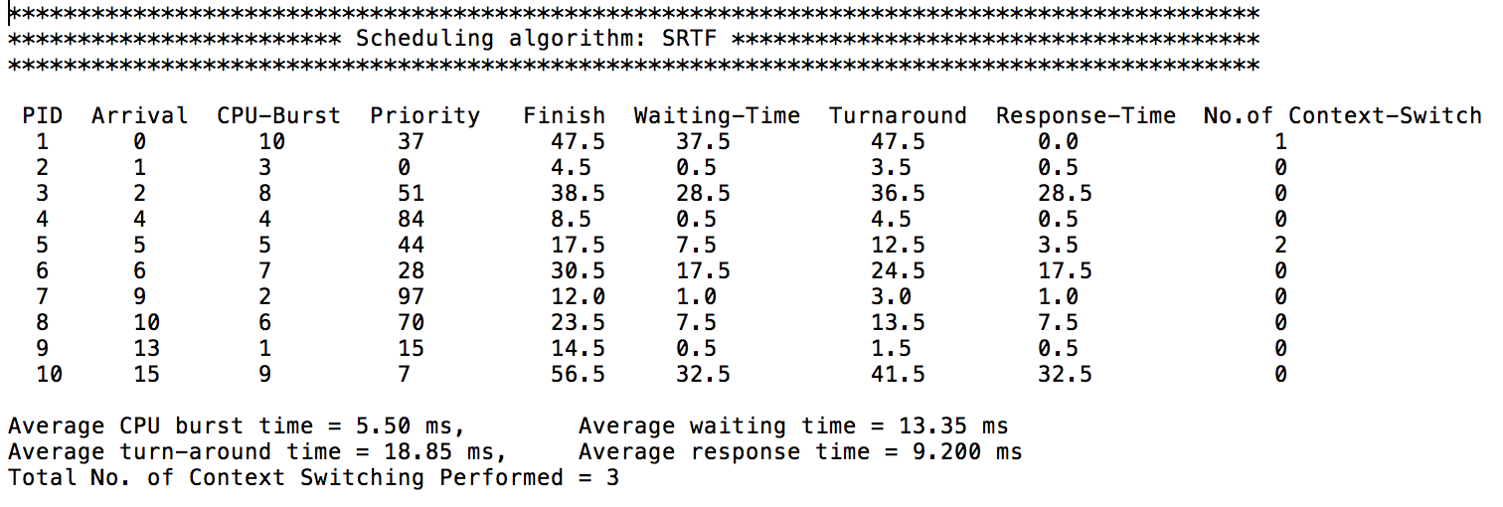

Output with command

**./myscheduler input100 output 1**

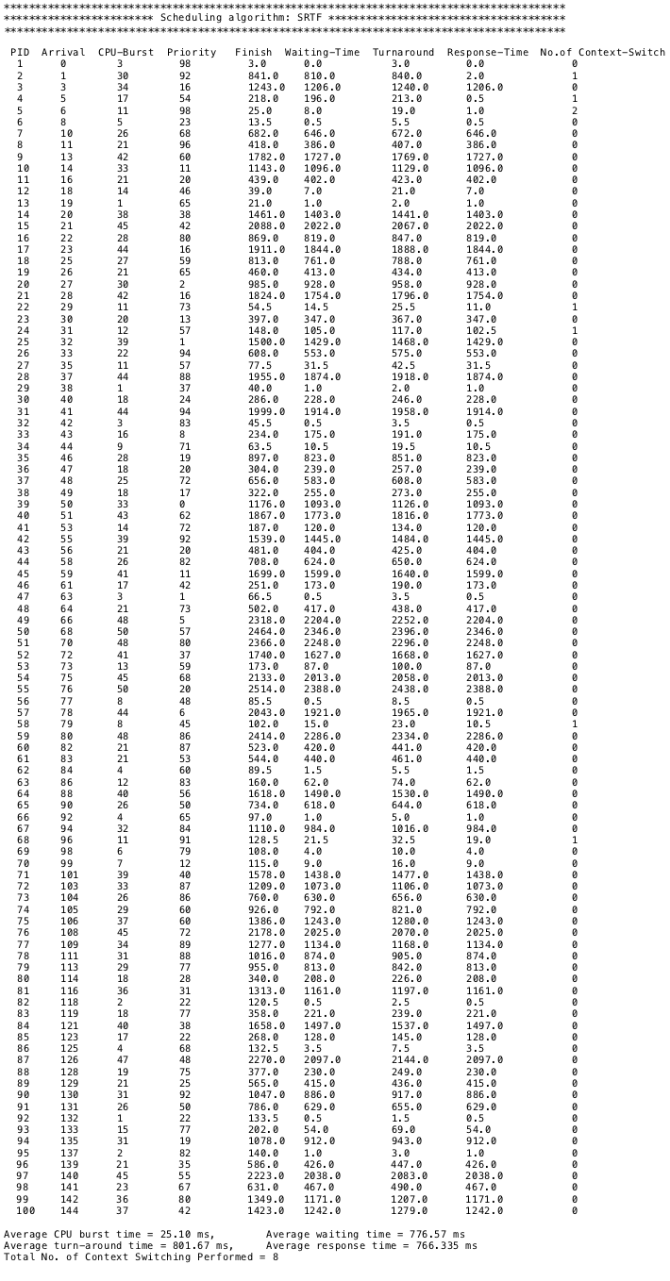

Output with command

**./myscheduler input4 output 2 3**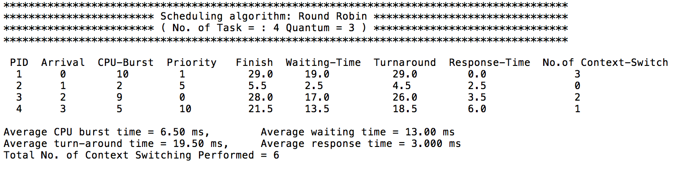

Output with command

**./myscheduler input4 output 2 4**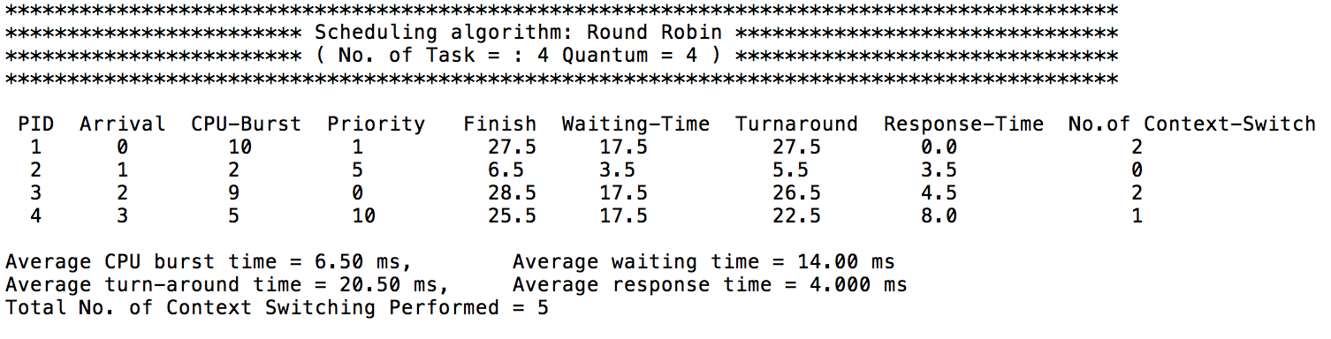

Output with command

**./myscheduler input4 output 2 5**

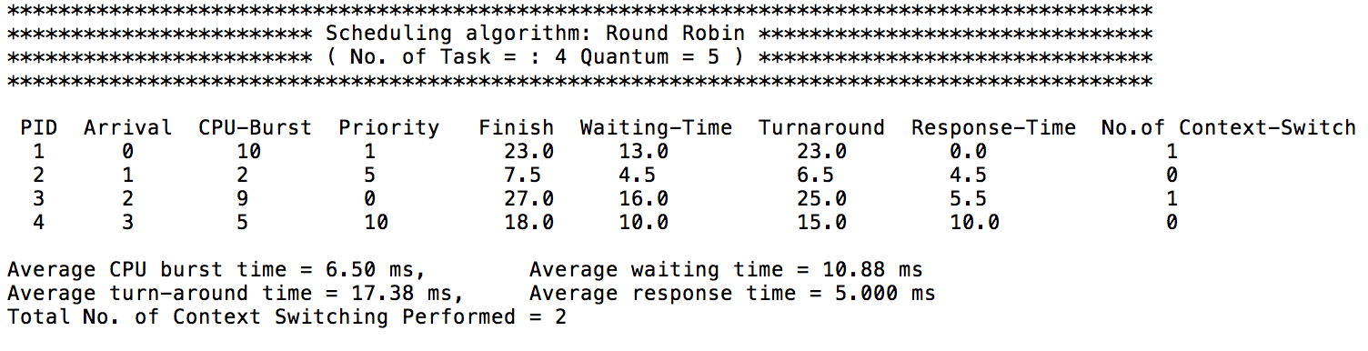

Output with command

**./myscheduler input10 output 2 3**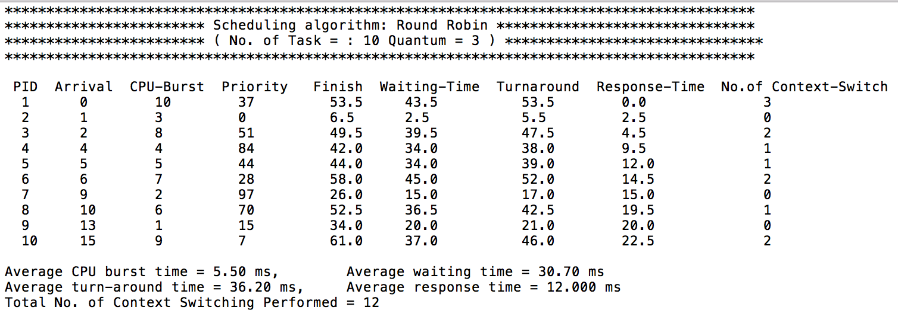

Output with command

**./myscheduler input10 output 2 4**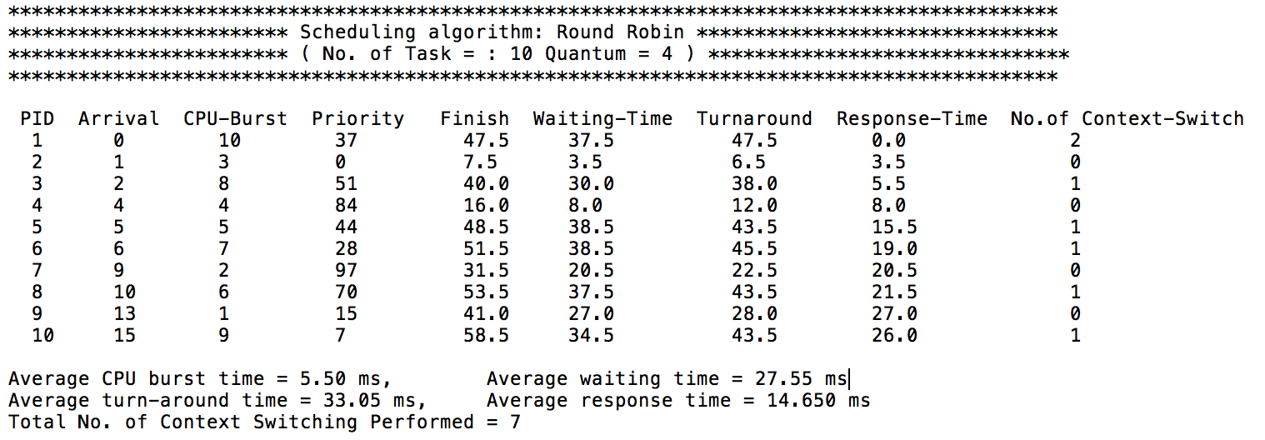

Output with command

**./myscheduler input10 output 2 5**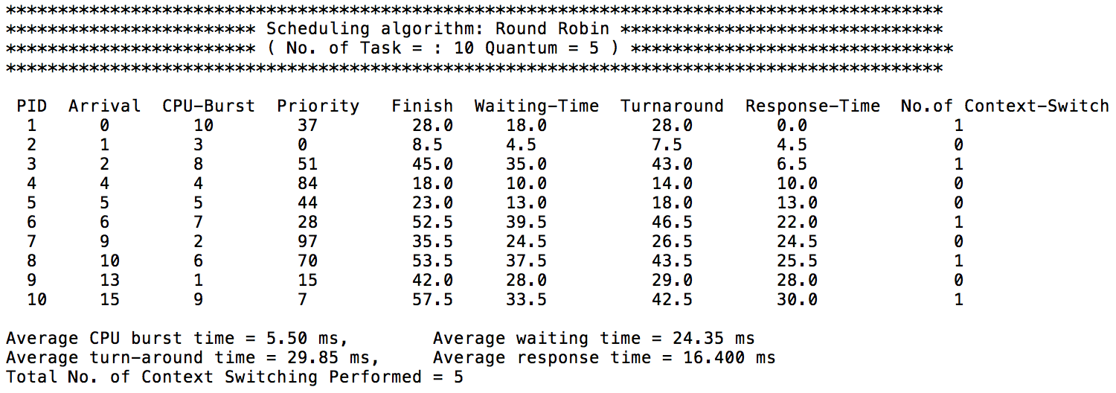

Output with command

**./myscheduler input100 output 2 3**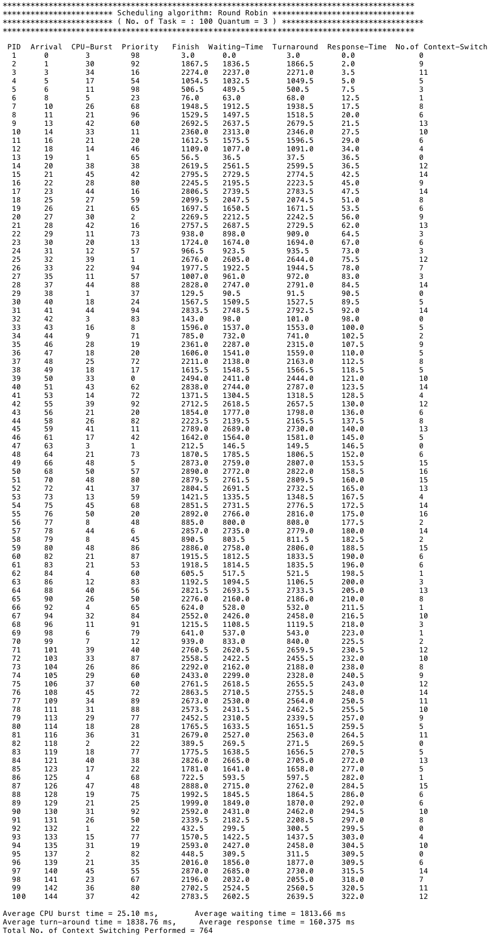

Output with command **.**

**./myscheduler input100 output 2 4**

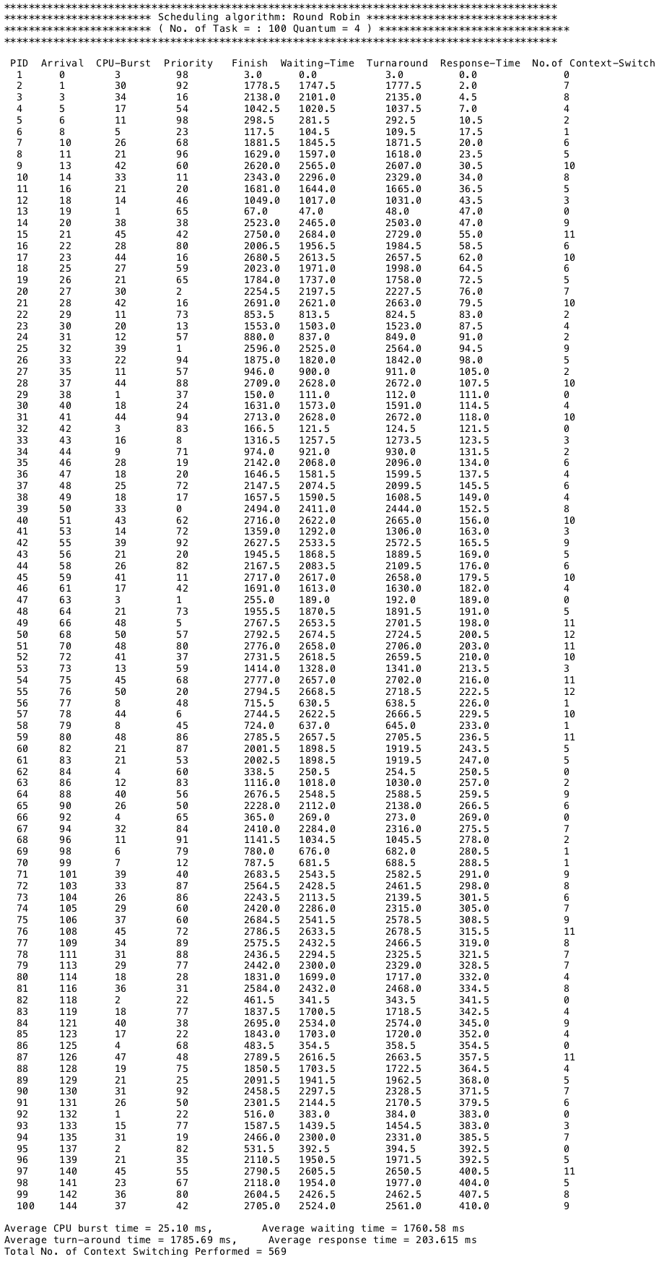

Output with command **.**

**./myscheduler input100 output 2 5**

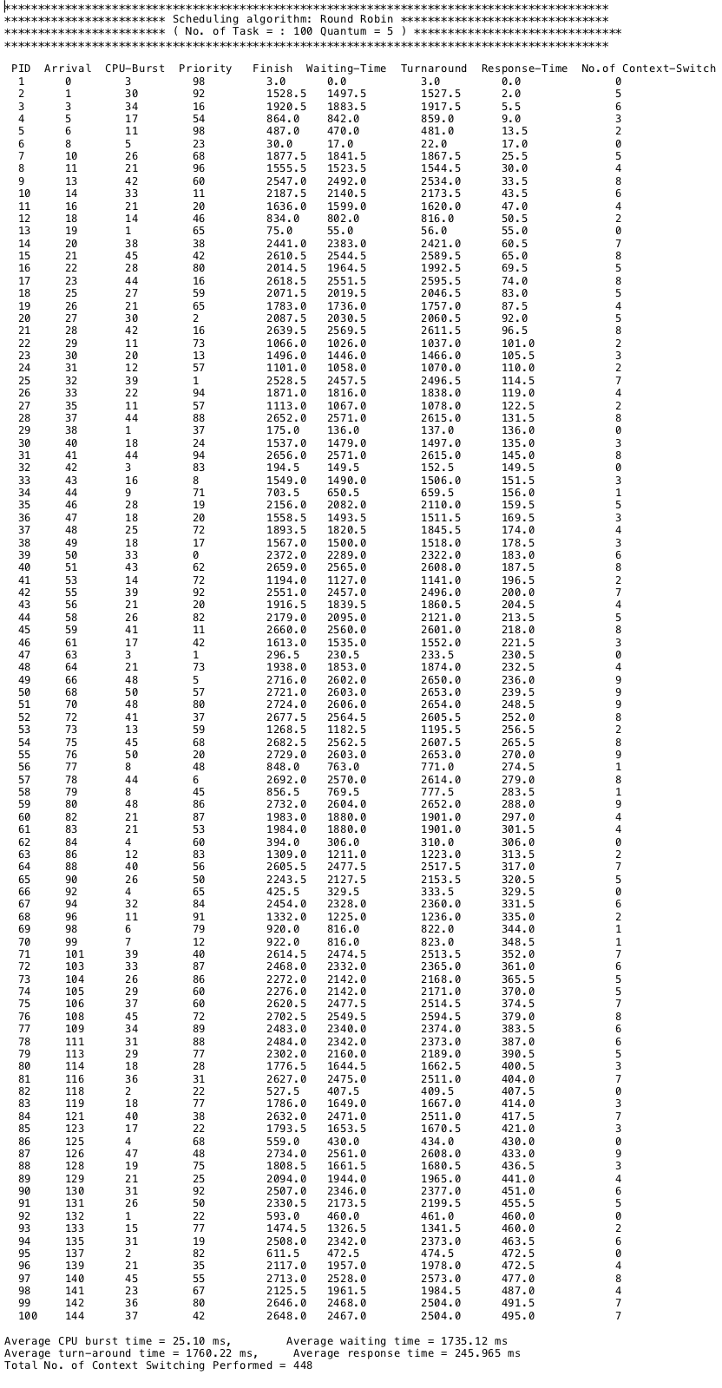

Output with command **.**

**./myscheduler input4 output 3**

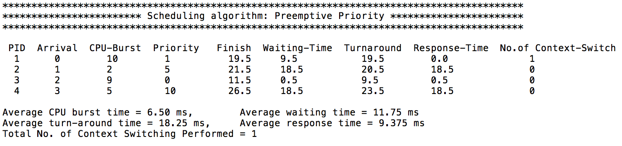

Output with command **.**

**./myscheduler input10 output 3**

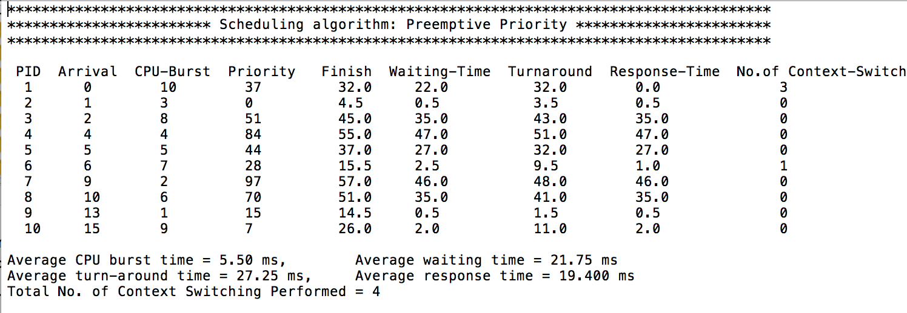

Output with command **.**

**./myscheduler input100 output 3**

